AUCTION
August 4, 2012 – 12:00pm
REAL ESTATE OF PEGGY SINK
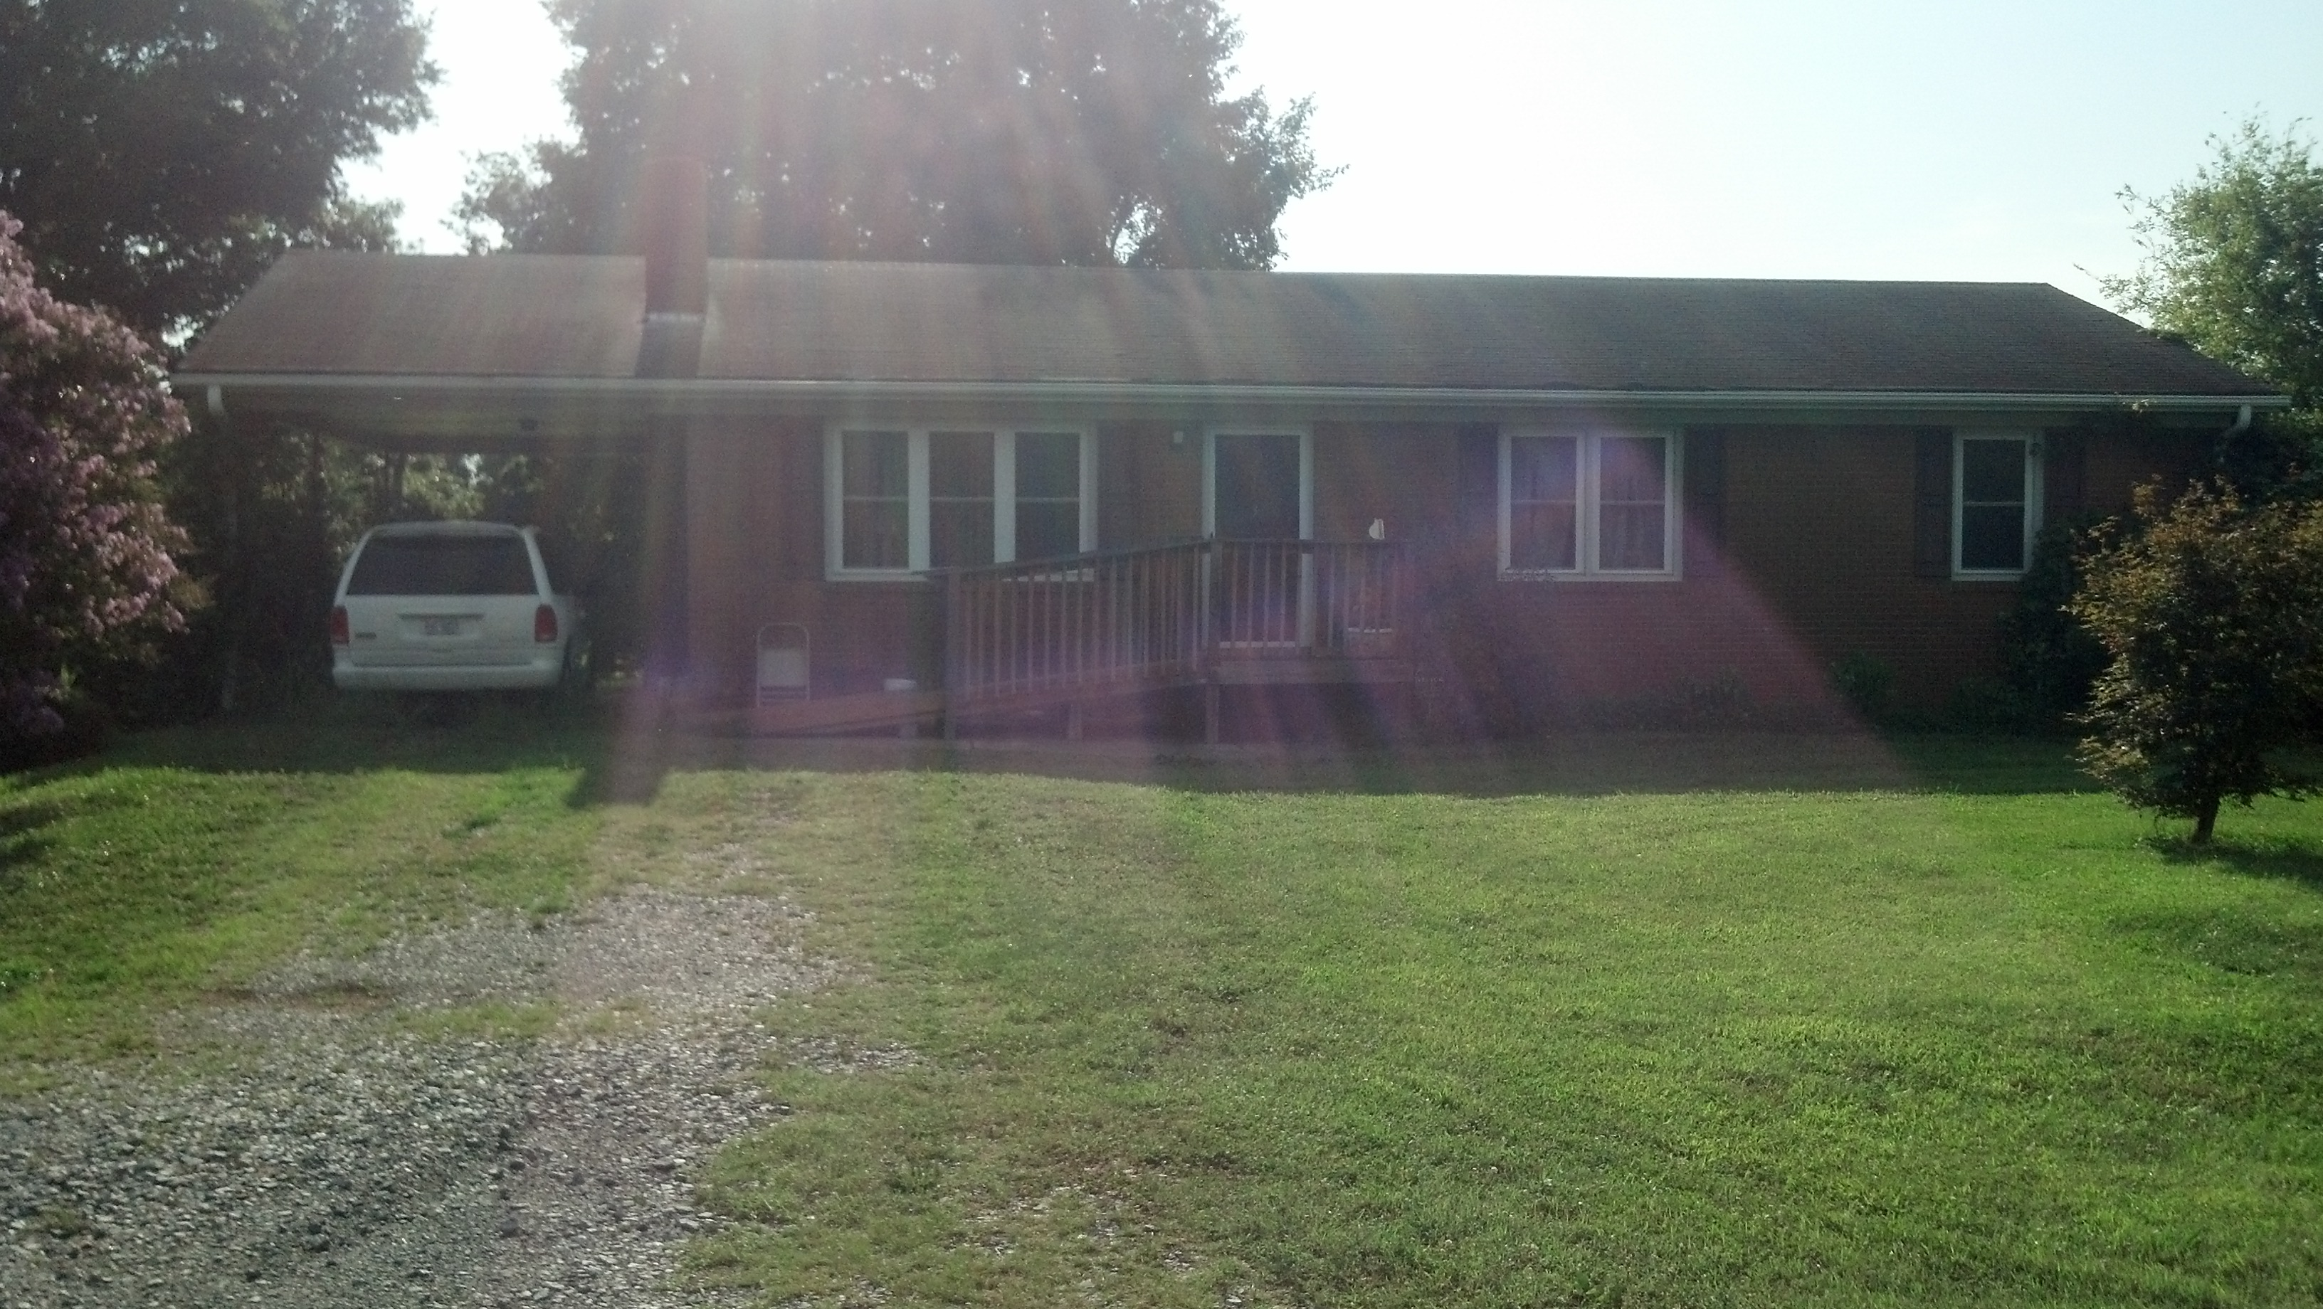
Sale Location: 143 JD Essick Road, Lexington, NC 27295
Directions from Lexington: 52N to first Welcome exit (old US 52). Turn Left. Left on City Lake Road. Left on JD Essick. First house on left

Real Estate to be auctioned consists of +/- 1400sf 3 Bedroom 1.5 bath Brick home with basement on +/-1.00 acre. Oil heat, Central Air Conditioning, Wood Stove, Hardwood Flooring. Property to be sold is a Portion of Tax PIN 6737-04-82-7790. Please see Residential Property Disclosure and Lead Base Paint Addendum before you bid.

Real Estate Terms of Sale: Real Estate offered for sale at 12:00pm, subject to confirmation. Real Estate is offered “As Is”. A non-refundable deposit of 5% of final bid price is due at time of sale. Balance due in 30 days at delivery of deed. No warranties other than closing title. All information given is per the tax record and should be verified as well as any/all inspections complete to buyer’s satisfaction before time of sale. Real Estate services provided by Angie Hart Properties, Inc. NCAF 8735 – Angie Hart NCREL 168350. Auctioneer services provided by Keith Yokeley – Auctioneer – NCAL 5323 - NCAF 8708

For information or to preview the property please call Angie at 336-764-4606.

